**Project ideas - User Interaction Design**

# Site Map

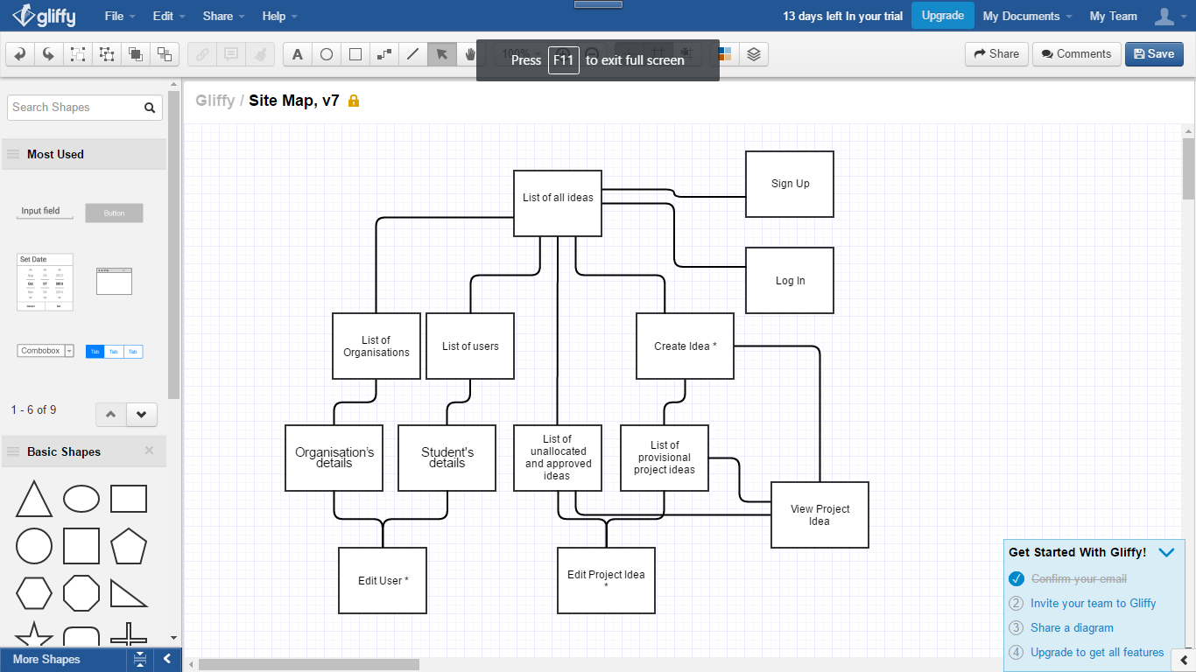

This is site map for the website. The pages with an asterisk next to it will need user to be logged in and authorised.

# Wire Frames

The main layout of all the pages will be consistent across the entire website to make sure users can easily understand and remember the site and not get confused with a different layout on every page.

The navigation will always be at the top of all pages to allow for easy and quick navigation to the main pages. Title on the left hand side as a link which leads to the Home page (All Ideas Page), Create Idea Page Which leads to a page which is used to create a new idea, Users Link which goes to a page to which allows to view the different users and lastly Log in Link which allows user to log in with their credentials which will change to Log Off Link if user is logged in already.

## Ideas Pages/Home Page

## 

The is the home page where it displays all the projects which has links to only get approved but unallocated projects as well as a link to get only provisional idea (only displayed for Admin users).

This layout is the same for 3 three pages, All Ideas, Approved but Unallocated and Provisional Ideas.

There is a search bar in these 3 pages, when the user inputs in the search bar the list will be updated.

## Users Page

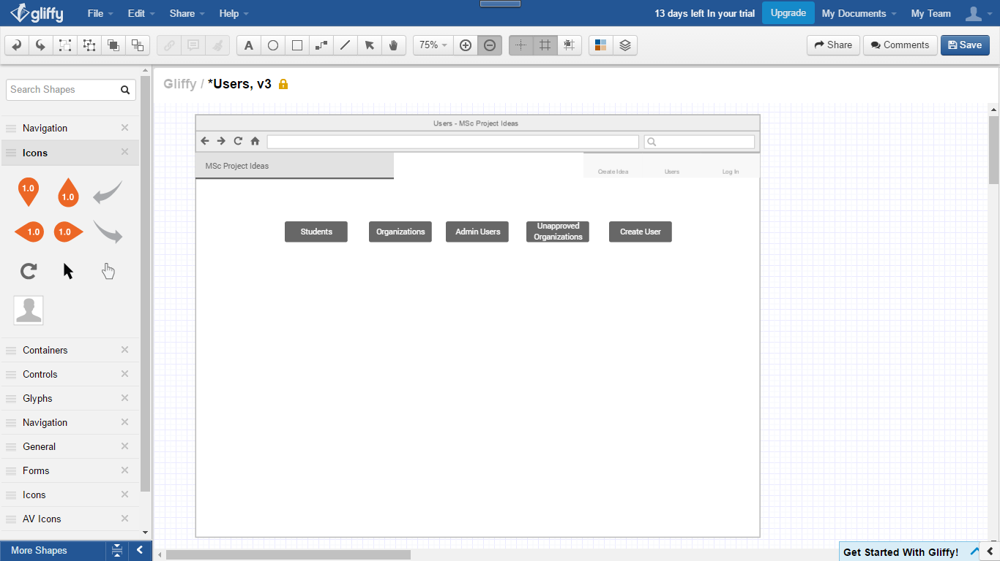

This is the page for Users, it will hold buttons/links to get a list of the Users such as Students, Organisations, Admin, Unapproved organisations. And a button/link to create a user. Admin, Unapproved organisations, Create User links/buttons will only be shown for Admin Users.

## Log in Page

## 

This is the Log in Page which allows all users to log in with their credentials they have been given or submitted, also a link/button if user is registered.

## Create A New Organisation

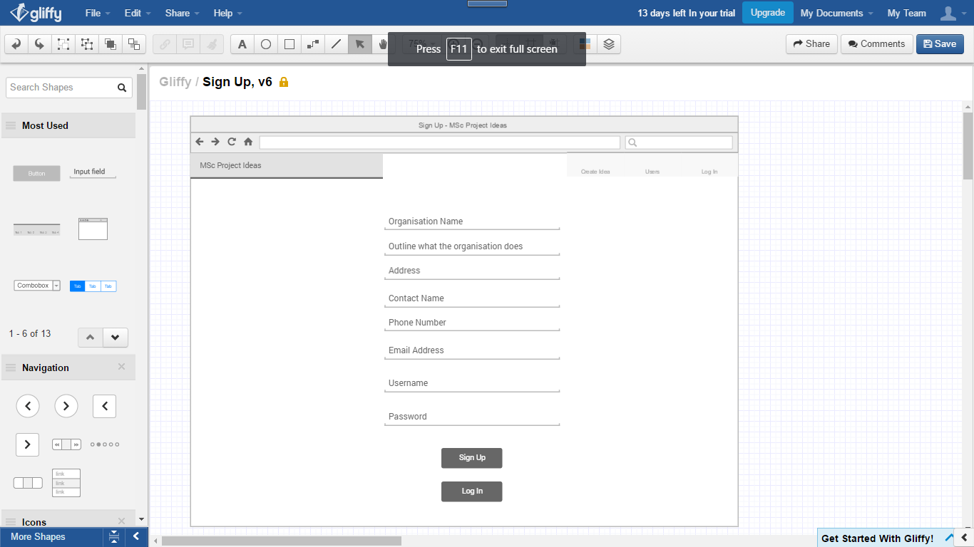

If the user is an organisation the user can use this page to sign up using the inputs provided.

## Create User

## 

Any Admin user can create a new user using this form. The inputs will change depending on what option of user is chosen on first select input. This layout will be used for the view student details page but with fixed text instead of inputs.

## List of Users Page

## 

The is the page where it displays all the users which has links to only get different types of users Students, Organisations, Admin Users, Unapproved Organisations. And a button to create a new user. But Admin Users, Unapproved Organisations and Create User buttons/links will only be displayed for Admin users. A

This layout is the same for the 4 pages Students, Organisations, Admin Users, Unapproved Organisations.

There is a search bar in these 4 pages, when the user inputs in the search bar the list will be updated.

## Project Idea

## 

Any logged in user can create a new idea using this form, and this will be used to edit an idea (only for submitter or a admin user). This layout will be used for the view idea details page but with fixed text instead of inputs will also have more detail on the submitter.